Possible proposed amendments for 12/9/2025 meeting
P. 83
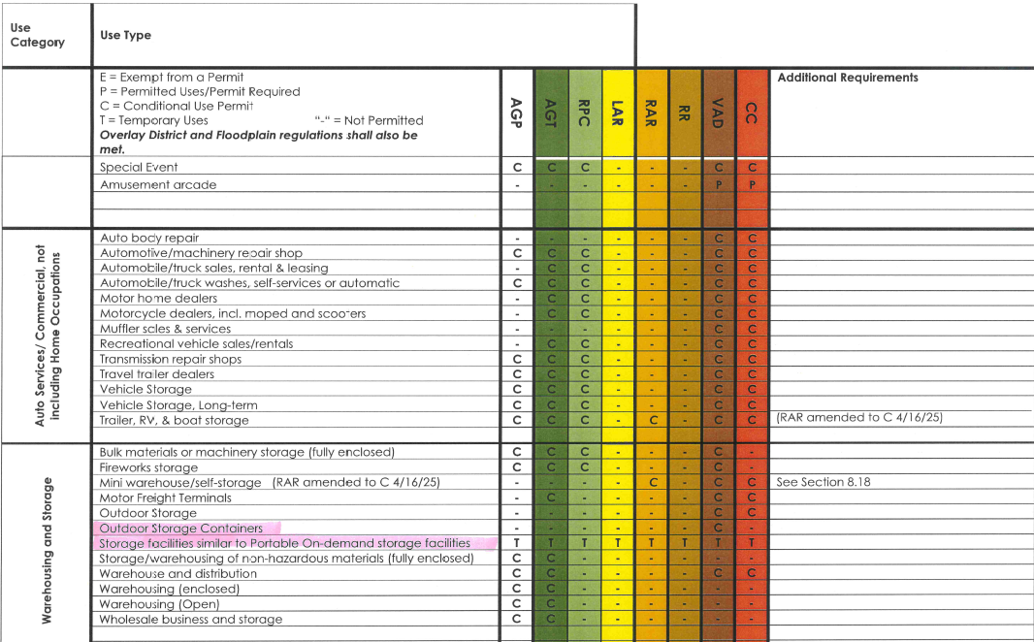

P. 86 Use Category – Accessory Use
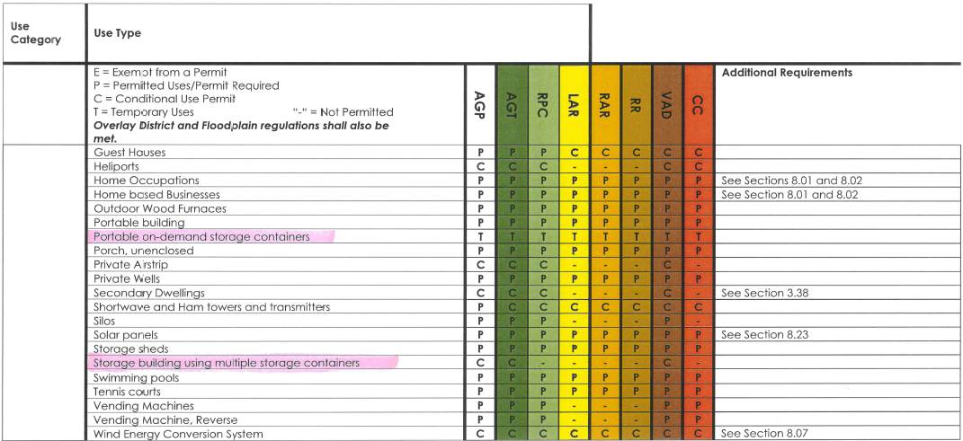
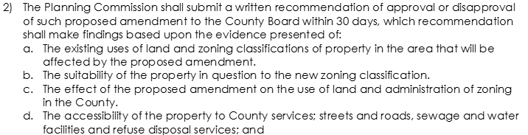

Definition found on page 57 of zoning regulations:
